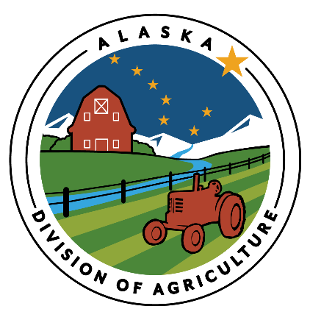
The USDA National Organic Certification Cost Share Program provides funding to assist with the costs of organic certification. Producers and handlers certified by USDA-accredited certifiers between October 1, 2022 and September 30, 2023 are eligible to receive reimbursement. Please note the funding this year by the USDA FSA will cover 75% of certification fees, up to a maximum of $750.

To apply for reimbursement, please complete this application and provide a copy of your organic certificate or letter confirming renewal. Also include copies of receipts or invoices documenting your certification costs. Submit fully completed applications no later than December 15th, 2023.

SEND APPLICATION AND SUPPORTING DOCUMENTATION TO:  Alaska Division of Agriculture  Attn: Organic Cost Share  1801 S Margaret Dr. Suite 12  Palmer, AK 99645 | Note:  All business-related information submitted or collected is confidential and exempt from public inspection and copying.

APPLICANT(S)

BUSINESS NAME (IF DIFFERENT)

MAILING ADDRESS

CITY |  | STATE |  |  | ZIP CODE
PRIMARY PHONE NUMBER | ALTERNATE PHONE NUMBER |  |  | FAX NUMBER
EMAIL ADDRESS |  |  | social security or tax identification NUMBER: REQUIRED
FACILITY/FARM LOCATION (BOROUGH) |  |  | MANAGER (IF DIFFERENT FROM THE APPLICANT)
Calculate your reimbursement:
Example: If your certification costs were $1000, you will receive 75% reimbursement, which would be $750. If your certification costs were $1500, 75% would equal $1125 so you will receive $750, as that is the maximum you may be reimbursed.
Certification fees paid = $ | X 75% (0.75) = $ (Maximum $750)

Signature of Applicant(s) Date
You must include a copy of your verification of certification, and itemized receipts or invoices documenting your certification costs.
NOTE: New applicants please complete a W-9 to receive funds.

